**Experiment name**

Evaluate fluorescent marker mobility/recruitment at the plasma membrane. Fluorophore is bleached by high laser power on ROIs, the fluorescence recovery on these is recorded in time lapses.

**References**

Simon et al. 2016, Platre et al. 2019

**Material and equipment**

- Chroma slide for calibration (https://argolight.com/blog/fluorescent-plastic-slides-field-uniformity/)

- Spinning disk confocal microscope equipped with FRAP module

**Hardware**

Spinning disk confocal microscope equipped with FRAP module

|  |  |  |  |  |  |  |
| --- | --- | --- | --- | --- | --- | --- |
| Microscope | Configuration | Laser properties (wavelength + intensities) | CLSM Detector  (detection window + gain) | Exposure time (spinning) | Other parameters  (Z-stack, time lapses) | Comments |
| Spinning Gonzales | FRAPCSU GFP  Bleaching: 15µm circular region  525/50 nm BrightLine® single-band bandpass filter | 488 full power for bleaching, 30% for recovery | / | 300ms | 90s of recovery in the paper  (could have been better with 120s) | 1x 2x 3x FAPP1 mCitrine lines in  Simon et al 2016 |
| Spinning Gonzales | FRAPCSU GFP  Bleaching: 15µm circular region | 488 full power for bleaching, 30% for recovery | / | 300ms | 90s of recovery in the paper  (could have been better with 120s) | GFP-ROP6  in Platre et al. 2019 |

**Biological material**

Line used for the experiments: Good controls (both positive and negative)

|  |  |  |
| --- | --- | --- |
| Marker lines | Resistance | Expected result |
| GFP-ROP6  in Platre et al. 2019 | Kana |  |
| FAPP1 mCitrine lines in Simon et al 2016 | Basta |  |

**Other material**

List there chemicals used or plastic stuff such as Labteck chambered coverslips

|  |  |  |
| --- | --- | --- |
| Reference | Concentration (stock and final) | Comments |
|  |  |  |
|  |  |  |

**Time and technical constraint**

**Precise description of the method**

**Microscope configuration:** Ensure that a FRAP illumination setting is selected (FRAPCSU GFP, FRAPCSU mCH, etc) and that journal tab is active but empty. Check that the switch at the back is straight (like on the picture) and not in a 45° angle. Open the Ilas2 and ensure that Targeted Laser/On fly and MDA are checked.

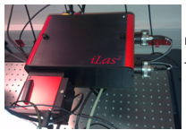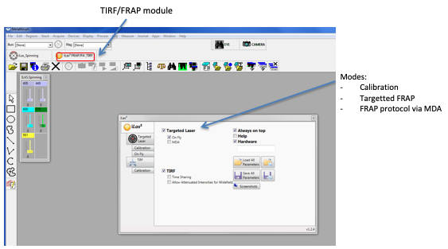

**Calibration:** Use the Chroma yellow slide located in the drawer next to the bench in the spinning area.

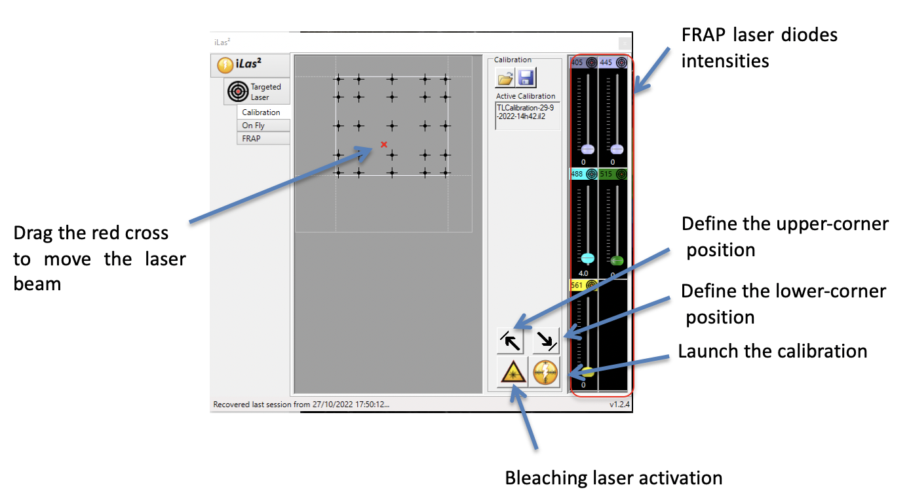

1. Place the slide on the stage and approximately reach the focal plane. All the slide is fluorescent so it might be difficult the reach a focal plane.
2. Go on the calibration tab in the Ilas2 window and set the bleaching laser at 4%. In the MDA acquisition time should be 200ms.
3. Activate the bleaching laser.
4. Adjust the focus to reach the smallest focal point.
5. Move it (in the interface) to the upper left corner of the field of view (live) and register the position in the Ilas2 interface. Repeat for the lower right corner.
6. Launch the calibration. At the end “Calibration OK “should appear in the Ilas2 interface. If failure and “multi-points were detected” either the laser power/acquisition time were too high or the focal plane was not adjusted properly.

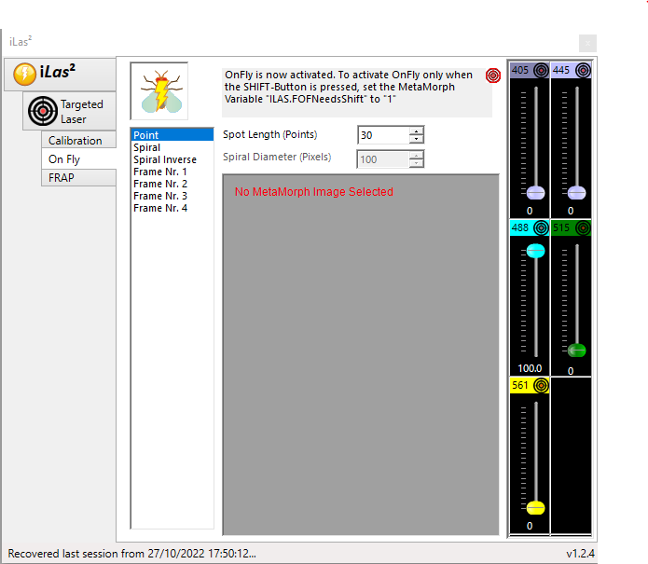

1. Go on the calibration tab in the Ilas2 and test the “on fly” mode. Launch live in the Metamorph MDA and target the bleaching laser by clicking on the live image. If correctly calibrated it should target the ROI (light flash).

**Acquisition:**

1. Set up acquisition time and laser power like in regular confocal mode with Time-lapse and journal clicked on.
2. Go to the Ilas2 interface FRAP tab where you can “design” the FRAP with 3 main steps (Pre-Bleach, Bleach, Recovery).

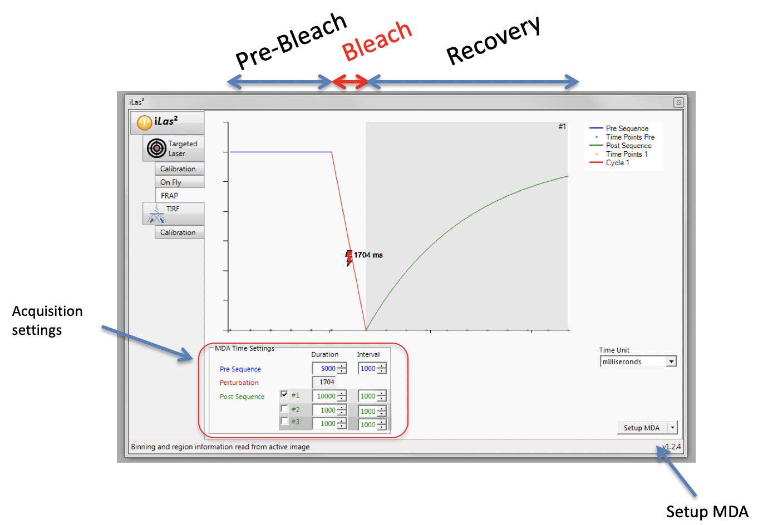

Pre-bleach: to estimate Initial intensities on your ROIs, couple of frames.

Bleach: Setup in the Targeted laser tab

Post-Bleach: to record fluorescence recovery, dependent on your sample. Tests have to be made to optimize this part. Intensities in your bleached areas must reach a plateau for accurate quantification, on the other hand photobleaching in the ctrl ROIS must be minimal. Can be made in several sequences: fast acquisitions during the first steps of the recovery, high frame interval later to reach the plateau.

1. Setup Pre and Post sequence phases.
2. Place your sample on the stage and go to the Ilas2 interface Targeted laser tab.

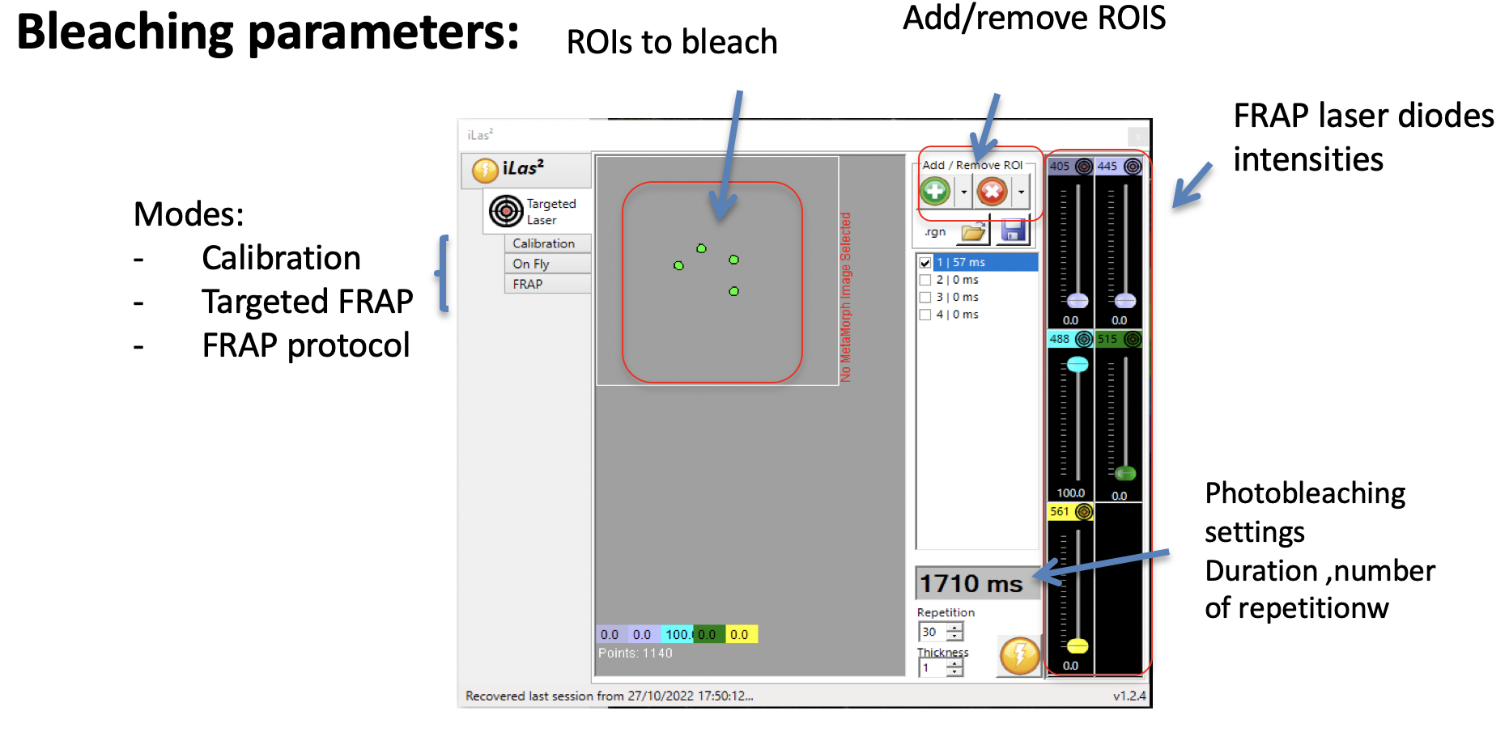

Save FRAP Ilas2 parameters

1. In the Ilas2 interface remove pre-existing ROIs. Set the laser power to 100% (for example 488nm for GFP), ensure that others lasers are set to 0.
2. Find your sample in live mode and take a snap to avoid bleaching.
3. Open the region tool in Metamorph and create circular region to draw bleaching region on the snap with width and length (usually used a circle of 40 x 40 px).
4. In the Ilas2 interface add ROIs.
5. Move pre-existing region and add new ROIs (typically 4 to 6). Keep in mind you will have in the analysis step to define a control region for each bleached ROI with almost same amount of fluorescence. Avoid designing ROIs on the edges of the field of view.
6. In the Ilas2 interface define the number of repetitions. How many times the high laser power will scan your ROIs. You must reach the minimal fluorescence intensity in the bleached ROIs with the minimal repetitions (no need to make 50 if 20 is enough). For your test experiment, test different numbers and check afterwards in FIJI. The parameters selected in the FRAP Ilas2 interface can be saved using the flat-disk icon.
7. Go back to Ilas2 interface FRAP tab and click on setup MDA.
8. Click on acquire in the MDA. Showtime!
9. The Ilas2 interface settings can be saved in the home of Ilas2 interface (button “save all parameters”) and reused (“load all parameters”). The number of repetitions is not saved, so remember to update this before you start an experiment.
10. In-between acquisitions, remove ROIs and back to step 14.
11. You can skip steps18-19 as the number of ROIs/repetitions and FRAP sequence should be the same.

**Critical:**

For your first experiment you will have to:

* Find good acquisition parameters. You need high S/R ratio but your want to avoid photobleaching. Balance between Acquisition time and Laser power is crucial.
* Find the bleaching conditions to reach the minimal fluorescence level in your ROIs (test different repetitions values: 10-20-30 for ex).
* Design post bleaching acquisition steps. THE critical point! Test different Duration and different intervals. Take a look at the fluorescence in FIJI using Kymograph and plot profile tools.
  + Load your acquisition in FIJI
  + Check noise by measuring a rectangular ROI outside the sample. Here it’s around 800
  + Draw a line on your bleached mb
  + Create Kymograph
  + Draw a line along the Kymograph and use Plot profile tool. In the example below the intensity starts from 5400, down to 1550 and recover to 4600 (Plateau at 150). Signal/Noise ratio=5400/800=6.75, it should be at least of 4.
  + Do the same a control region. Here it starts from 6250 to 5500 and the end of the acquisition, and around (6100 at 150). So, I can make the analysis.

